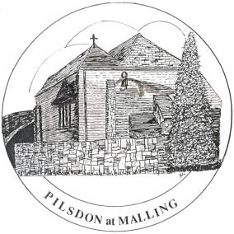The Pilsdon at Malling Community

**Community Member Vacancies**

Would you like to be part of a working and caring community with a real purpose? If so, we are looking for new members. We are an ecumenical Christian charity that takes in, walks with and encourages people recovering from crises in their lives. And we live in an old monastery on the outskirts of a beautiful Kent village, looking after a six-acre smallholding.

Community Members, led by the Guardian, make up the core team who together take responsibility for maintaining the Christian ethos and managing the property. We live alongside our volunteers, guests, visitors and occasional wayfarers.

You will need good practical and pastoral skills. All members take part in the day-to-day running of the community. Our work includes cooking, cleaning, gardening, looking after livestock and helping in the office. A Community Member also acts as a support / link to a number of resident guests. Above all, we look for the qualities of Christian commitment, resilience, trustworthiness, kindness and compassion.

For further information, please contact the Revd James McKeran at [guardian@pilsdonatmalling.org.uk](mailto:guardian@pilsdonatmalling.org.uk) or phone for a chat on 01732 870279.

